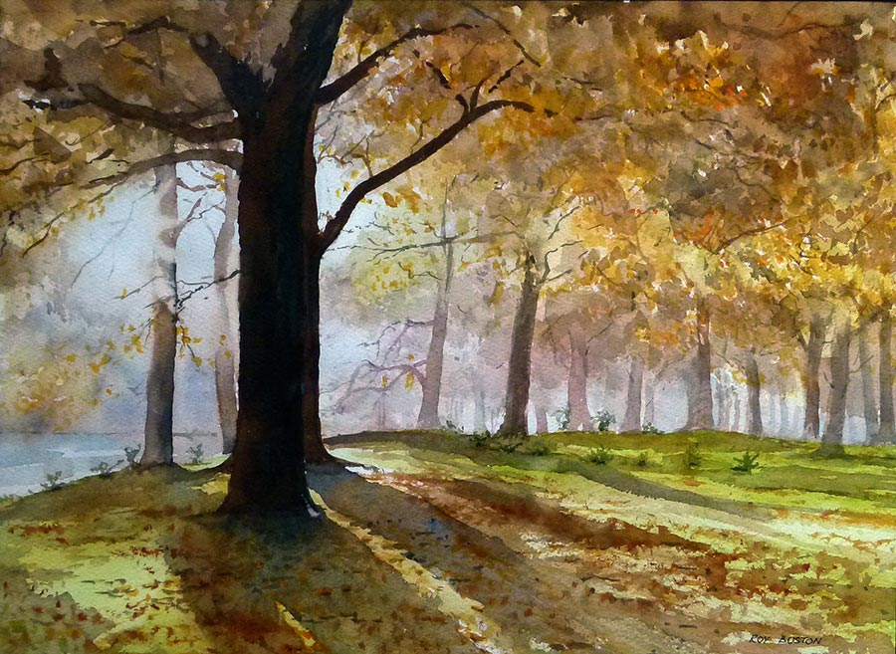

Photo: Hagley Park by Roy Boston

Art on the Shore Exhibition Opening

Takapuna Library

**Welcome to an art exhibition in support of Cyclone Pam recovery in Vanuatu. Paintings are a mix of watercolour and acrylics by artists from the Auckland Watercolour Society**.

**All paintings are also for sale and are cash and carry.**

|  |  |
| --- | --- |
| Where**:** | **Takapuna Library, 9 The Strand, Takapuna.** |
| When: | **The exhibition opens on Monday 8 June and runs to Sunday 21 June. Opening event** - Refreshments start at 6pm with a 6.30pm opening. Bookings recommended. |

Please RSVP for the exhibition opening to

Helen.Woodhouse@aucklandcouncil.govt.nz or phone 890 4903.

**Find out more:** call 09 301 0101  
visit aucklandlibraries.govt.nz

 

Facebook – Auckland Libraries  
Twitter – @Auckland_Libs